April 14th, 2021
Dear Editor,
I am pleased to present our paper entitled “Use of a novel biomechanical model based deformable image registration (DIR) for assessing colorectal liver metastases ablation outcomes.”
With respect to the major contributions of this work, we feel that it deserves consideration within this journal for several reasons. First, our paper shows the importance of consideration of the deformation in the liver, and especially how rigid registration can lead to a false sense of achieving sufficient ablation margins in certain cases, Figure 1. Second, we demonstrate how our clinical workflow with a novel biomechanical registration, which has previously demonstrated accuracy in deforming homogenous structures in CT, can provide actionable intra-procedural information that might assist the interventional radiologist to assess treatment endpoints. Third, the prospective application of such methods has the potential to positively impact the local outcomes of colorectal liver metastasis ablation.
Dr. Brock and Cazoulat reports grants from National Institutes of Health R01CA235564, grants and licensing agreement from RaySearch Laboratories, outside the submitted work. Dr. Odisio reports grants from NIH, him and Mr. Anderson report grants from Society of Interventional Radiology.
We hope this work will be found appropriate for The International Journal of Medical Physics Research and Practice.
Sincerely,

Brian M Anderson, on behalf of all authors
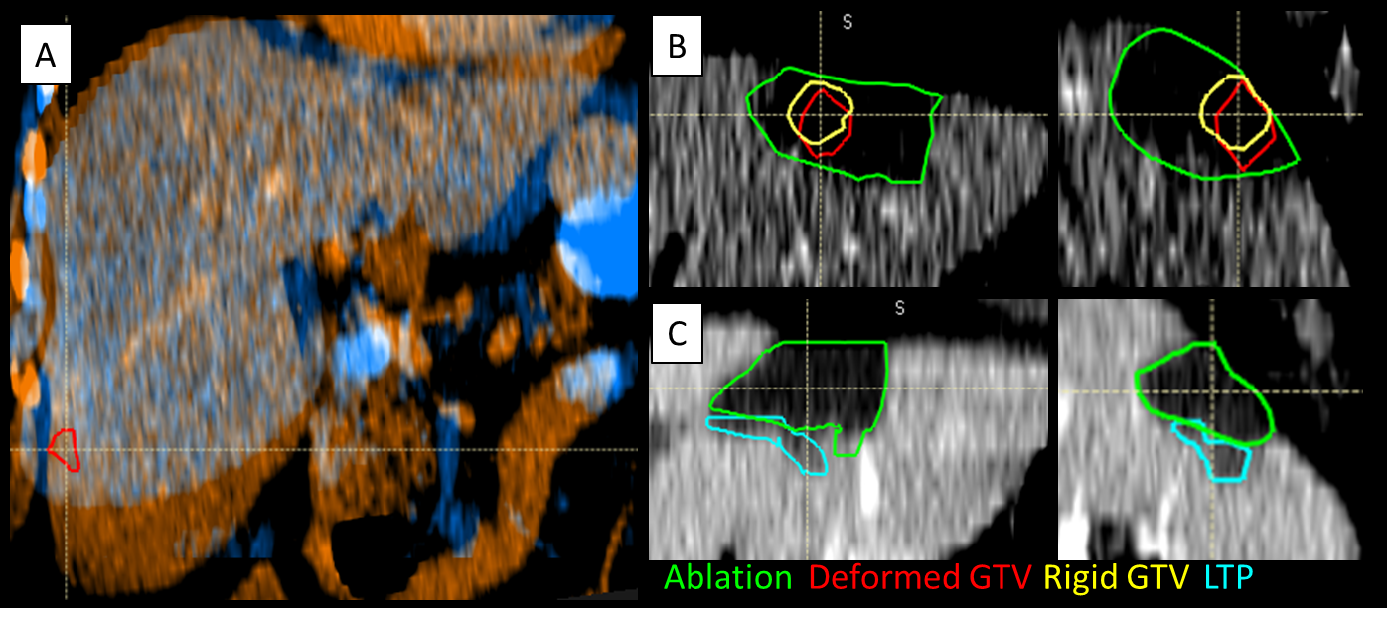
Figure 1: (B) Rigidly propagated gross tumor volume (Rigid GTV, yellow) appears to have sufficient ablation margin. However, deformed GTV (red) shows the disease proximal to caudal aspect of the ablation zone (green). (C) Local tumor progression (LTP, teal) corresponds geographically with insufficient ablation margin shown by the deformed GTV.

